Deploying BTEMessageTracker to New Windows 2019 Server – VMDATAAMFGWEBT

Windows Authentication was not installed

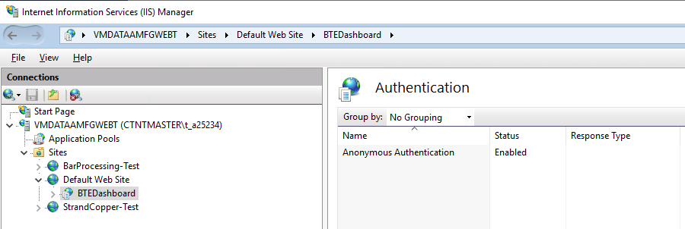

I installed in on the server - VMDATAAMFGWEBT

|  |  |
| --- | --- |
|  |  |